Create Node-RED Service

|  |  |
| --- | --- |
| **Name** | **ABINEETHA M** |
| **Register Number** | **710719106004** |
| **Project Name** | **Project - IOT based safety gadget for**  **childsafety monitoring and notification** |
| **Maximum Marks** | **4 Marks** |

Aim:

To create a web application creates a Node-RED service.

Steps followed:

* Navigated to the App creation page

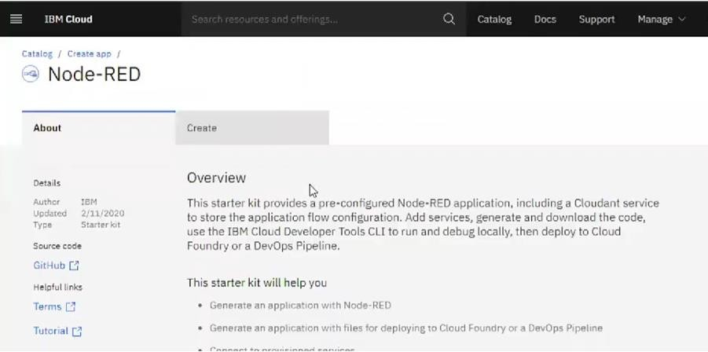

* + Entered project details and clicked on create

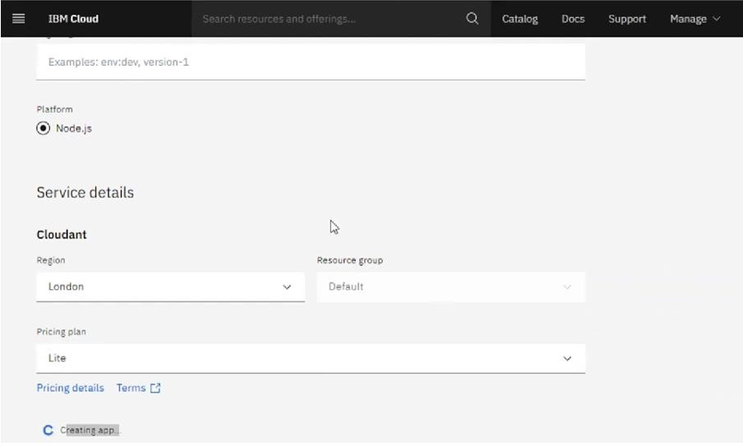

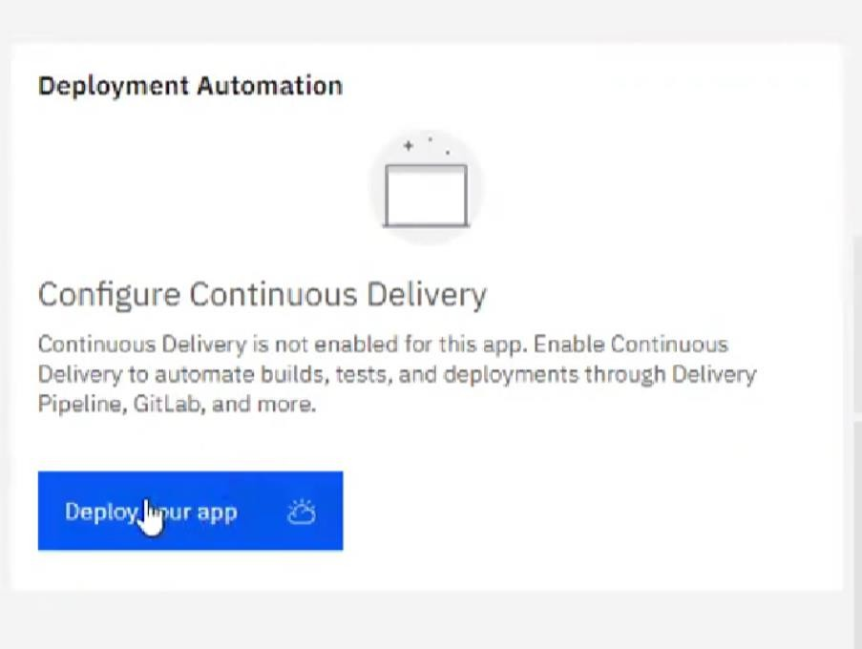

* Setting up the environment and deploying the app

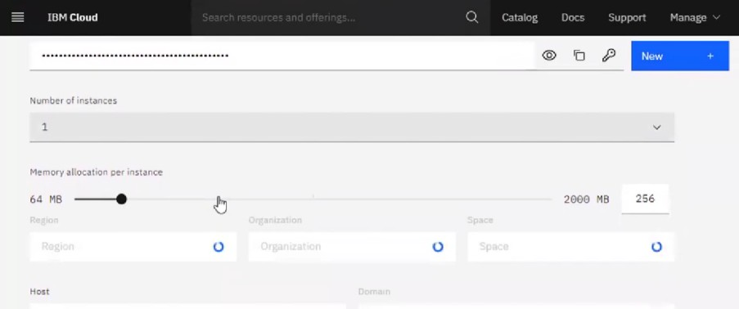

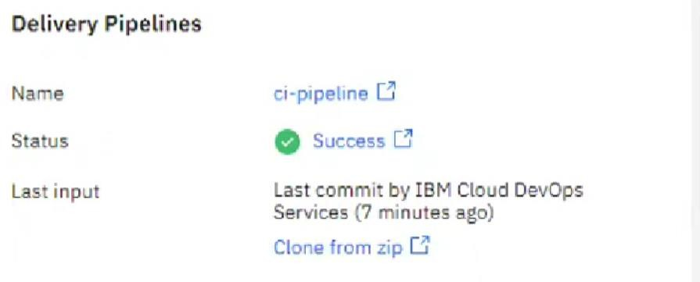

* Dragged and dropped components into the editor

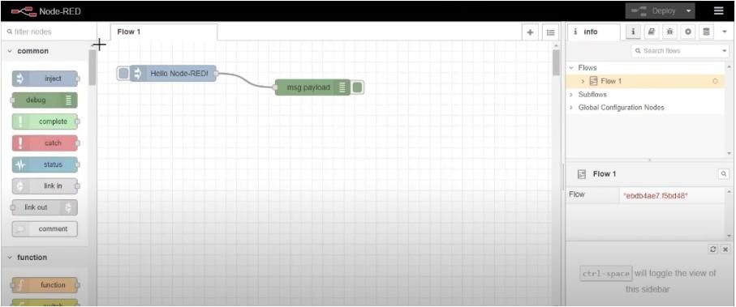

* Editing some values of the properties

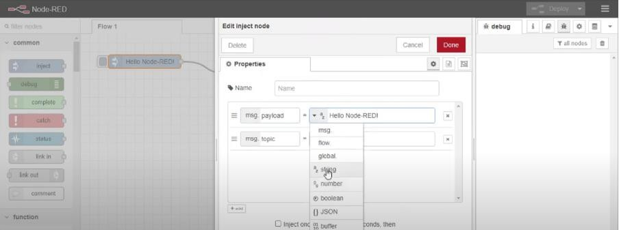

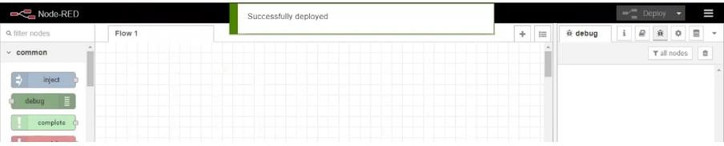

**Result: Successfully created a NodeRED service on IBM Cloud**